1. 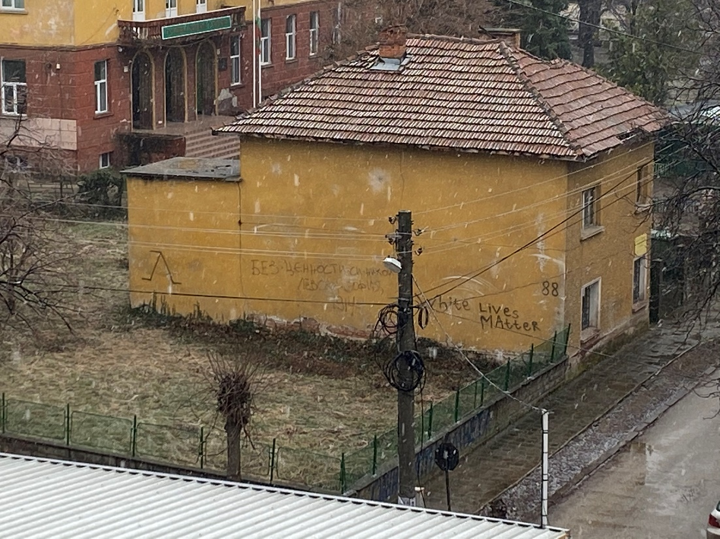After 2 tours of the city (once on foot and one with Google Maps) I found that in the city there are no places where there is graffiti or painted walls (I remember that there was graffiti in the underpass, but it is impossible to go, because from 6-7 years there is no electricity and there are all kinds of rodents). That is why today I will show one of the few acts of vandalism in our city. This is an inscription on a house next to the school where I studied. As you can see, the inscription was made by supporters of a football club (one of the many inscriptions in the city). Every year, most often in the spring, the places where there are such inscriptions are painted, but immediately after that they reappear. I love sports, but I don't understand what people prove with their actions. In my opinion, this is absolutely meaningless, as there are many other ways to express love for a particular team (sport).
2. Topics:
3. for a favorite sport
4. for a favorite movie
5. for your favorite music genre
6. for a favorite book
7. for the place we dream to visit